Locations in Leonem

SHOPS AND AMENITIES

McChub
McChub has three fast food establishments in Leonem. One is located in the center in Central Square, and the other two are located in the residential areas. Many residents in Leonem eat there on a regular basis.

Bet World
Bet World is a commercial center that contains mostly betting and gambling shops in the center of Leonem. The site is very spacious and well-located. However, there has been growing criticism of this establishment from the local community over an increase in gambling addictions in Leonem.

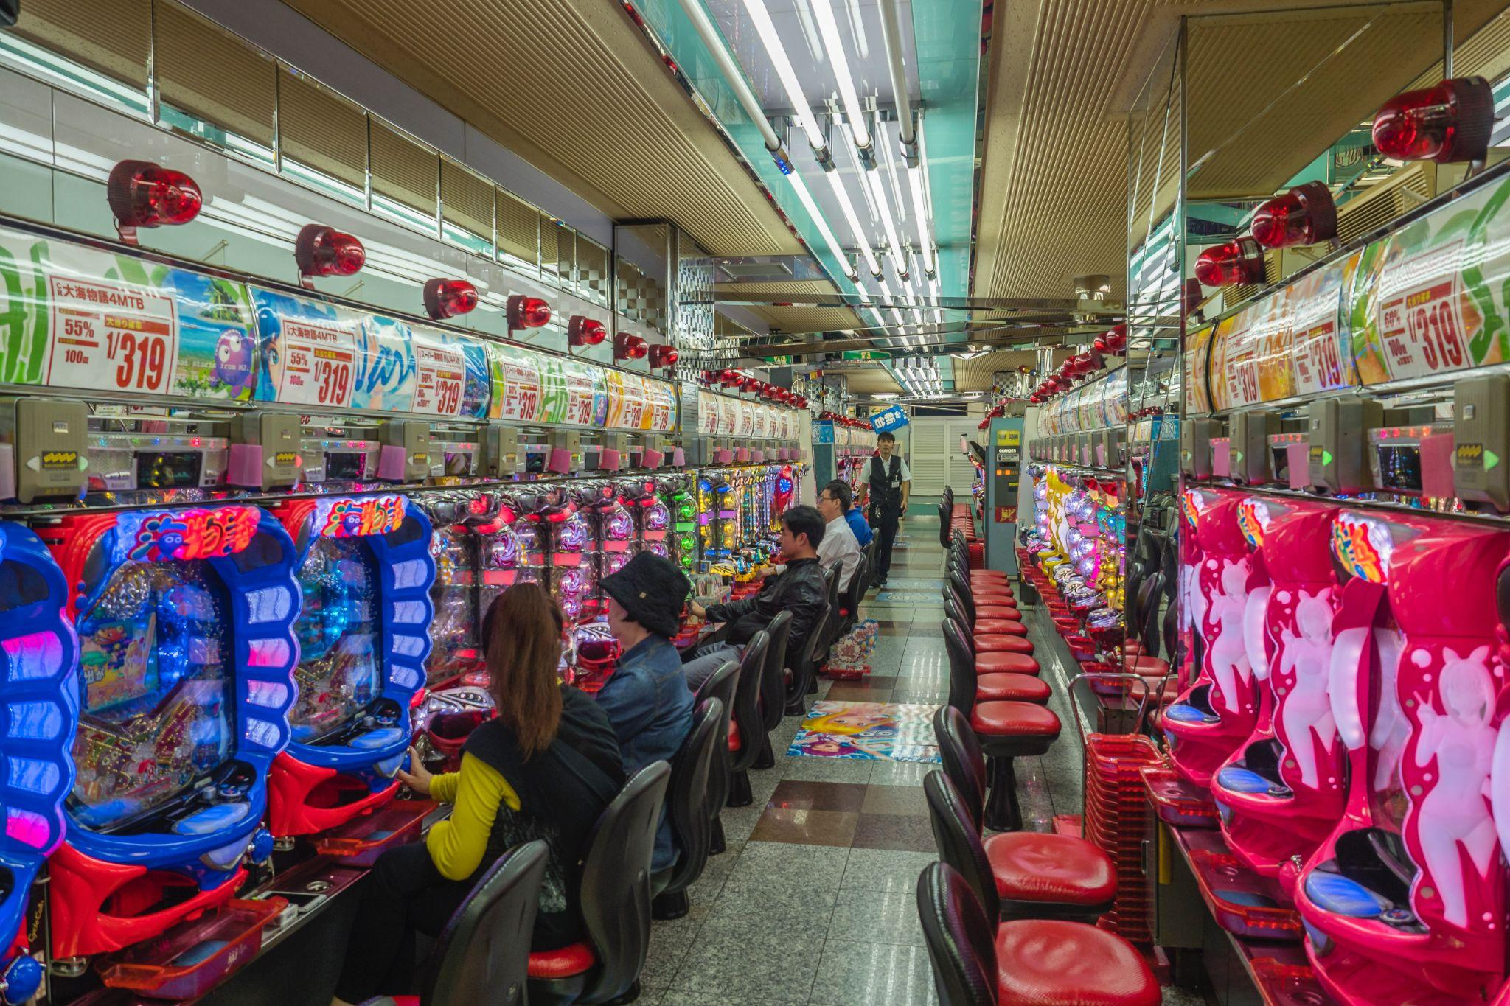

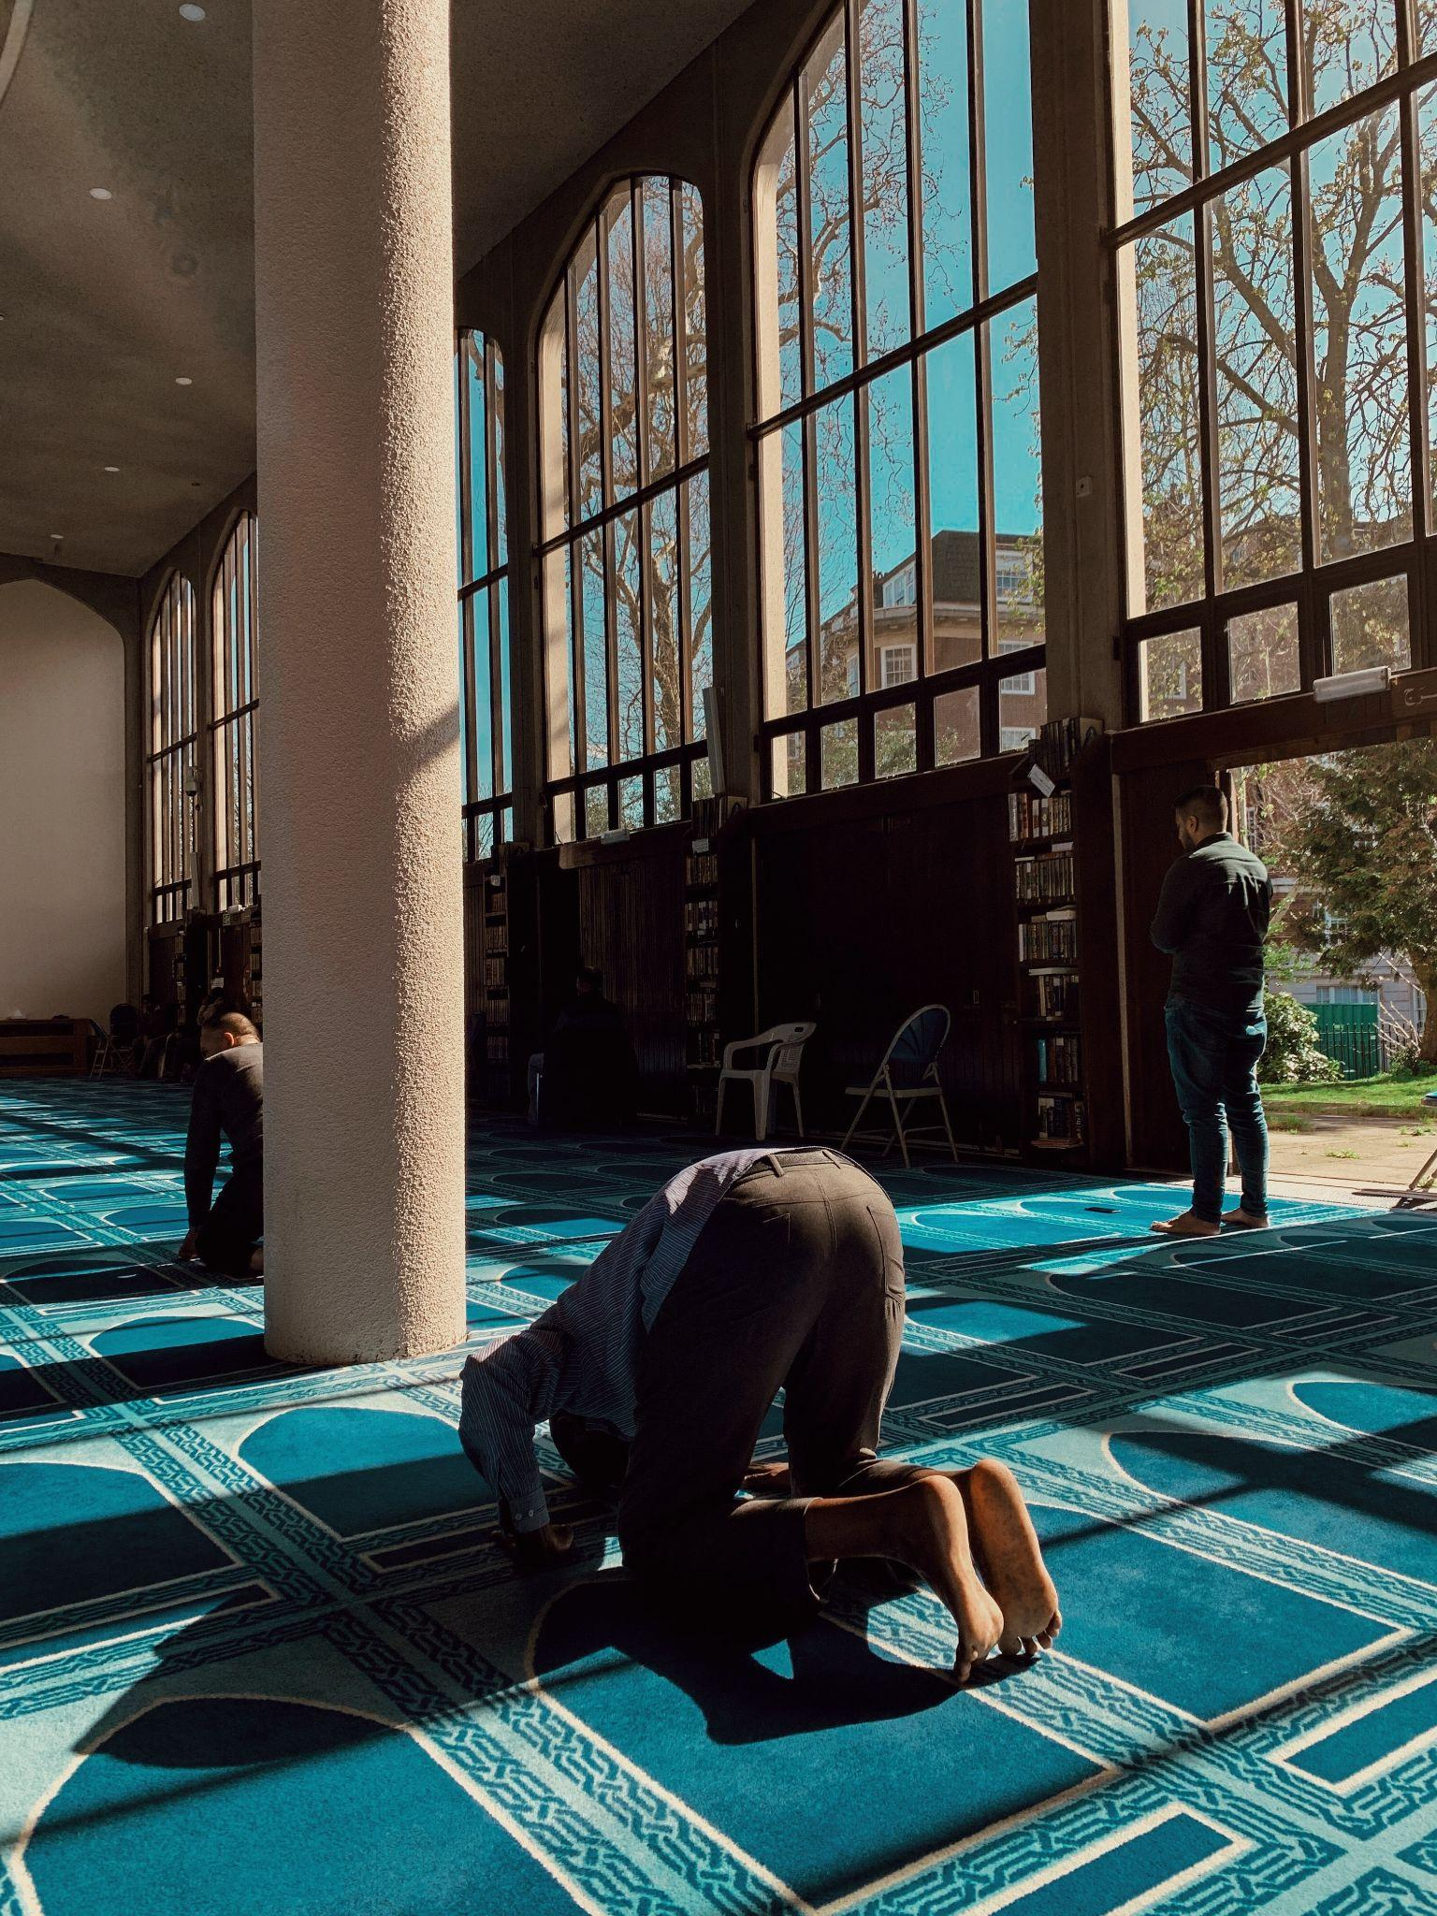
COMMUNITY SITES

East Leonem Mosque
This mosque is very dear to the local Muslim community in Leonem. However, in recent years it has become more crowded and soon will not be able to host all the people that would like to visit it. It is located in the residential area of New Leonem.

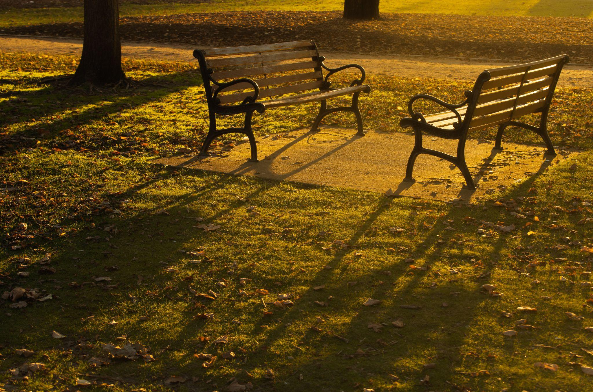

Leon Garden
Leon Garden is located in the center of Leonem. It is a local park with some trees and benches. Not only is it frequented by many local people who meet up there, it is also a place where local children play. However, at night it becomes an unsafe area, where crimes are reported occasionally.
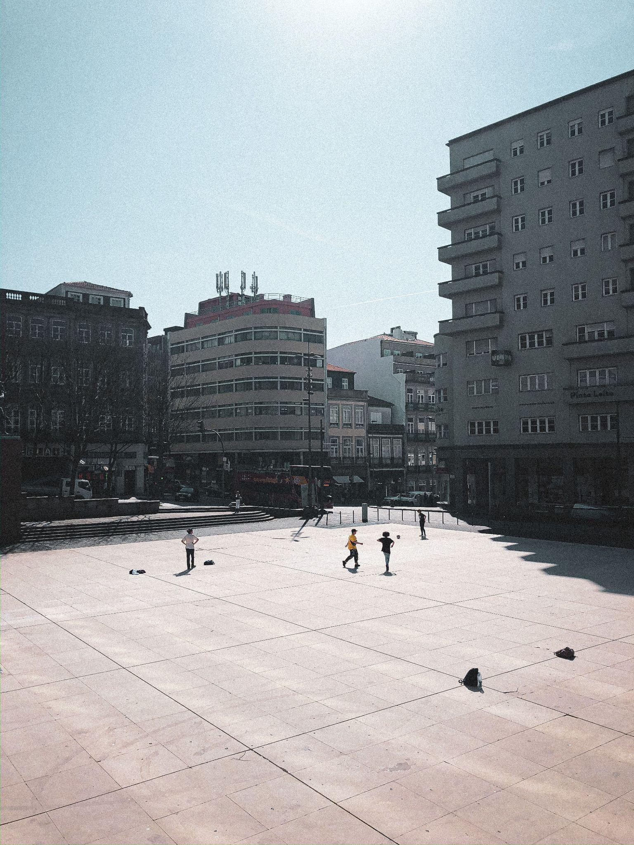

Central Square
Central Square is a plaza in the center of Leonem. It is a meeting place for many young people in Leonem, who like to skateboard there.

ABANDONED SITES
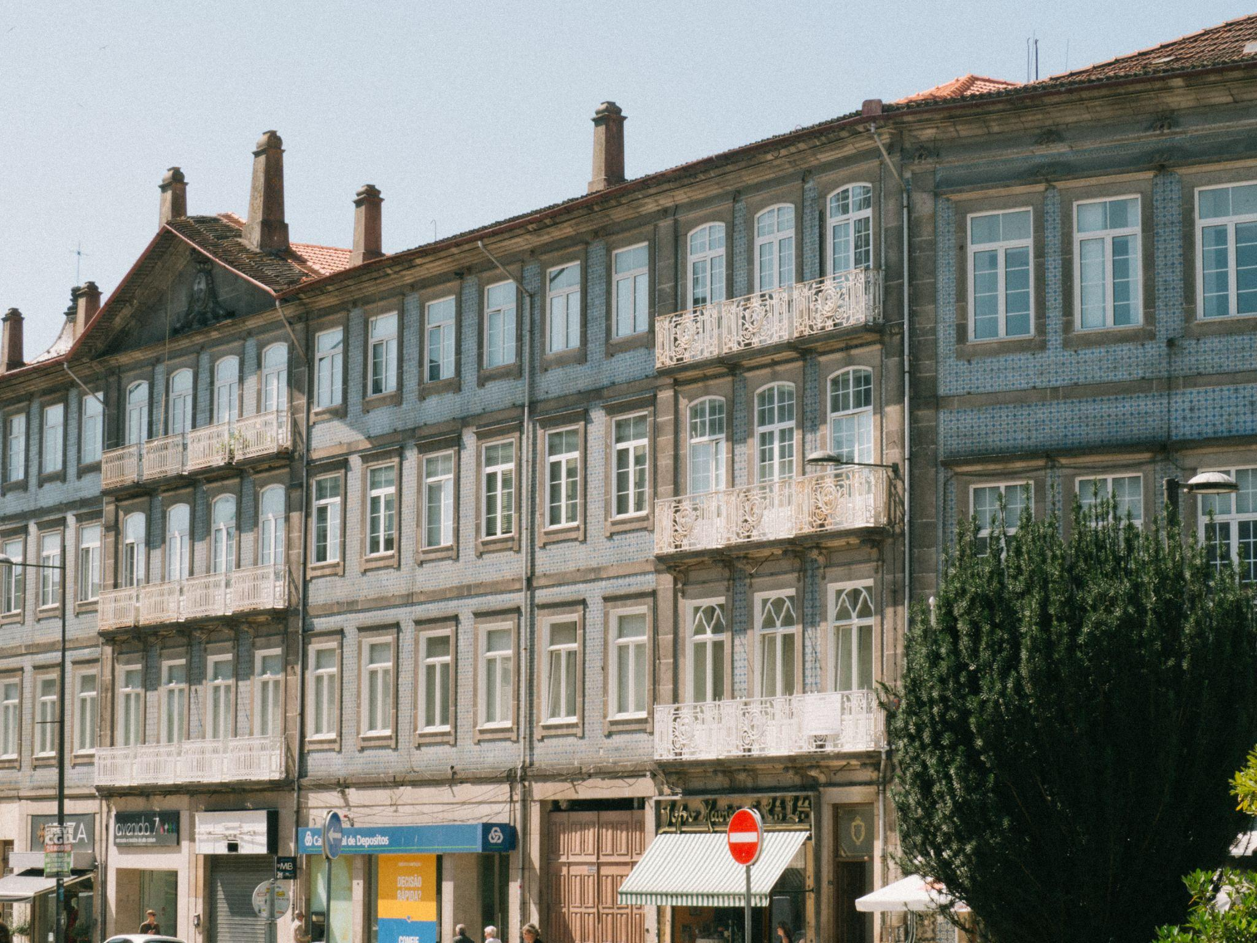

Old town hall
The old town hall used to be a beautiful building in the centre of Leonem with a unique architectural style. A few years ago, the town hall was moved to a different location, so this site has become abandoned.

The tobacco factory
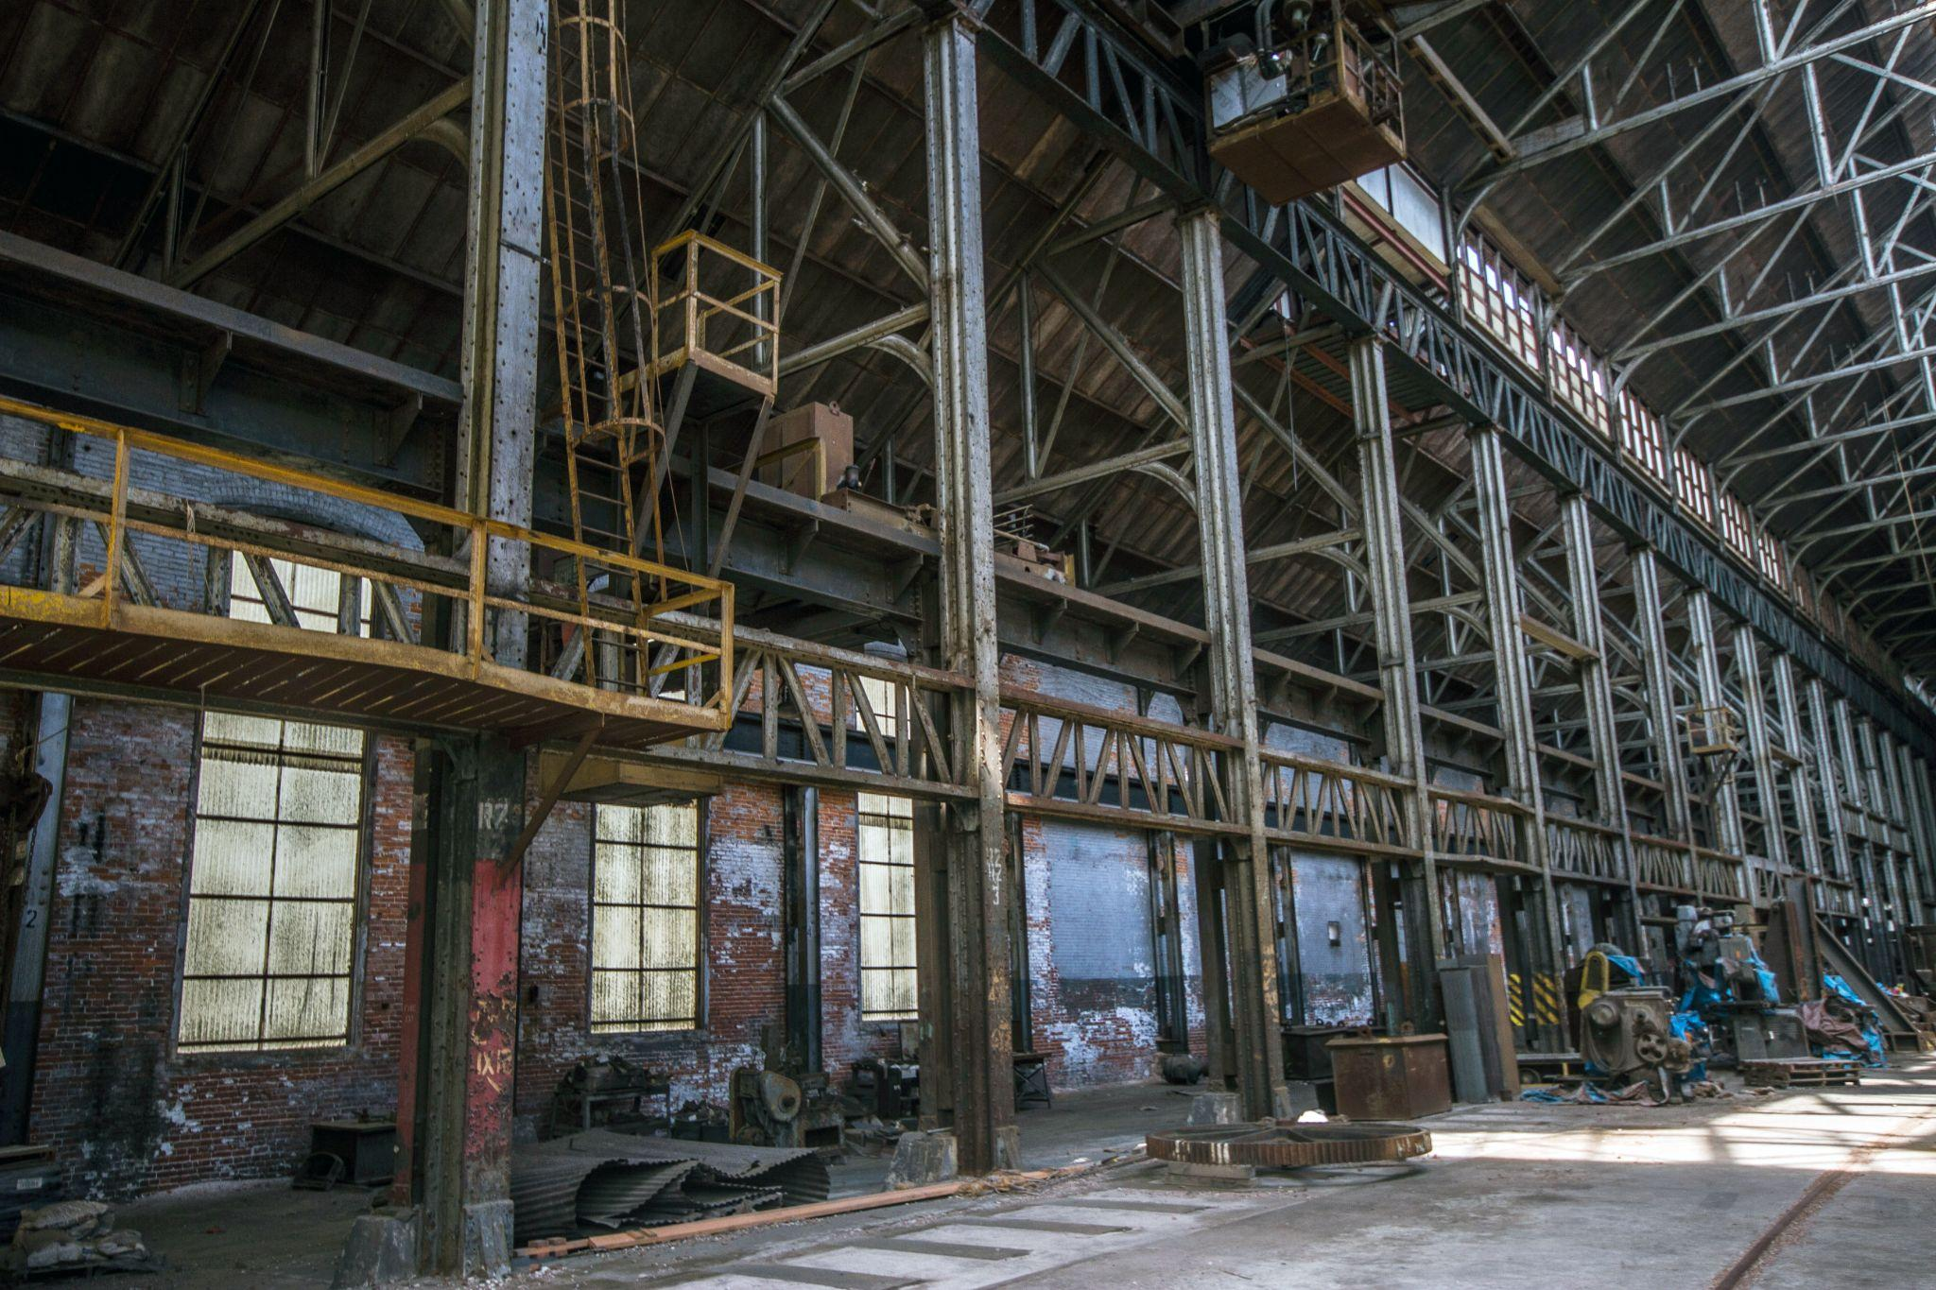
Near the residential area of Old Leonem lies an abandoned and derelict tobacco factory. It has very high ceilings and is very spacious on the inside.

RESIDENTIAL AREAS
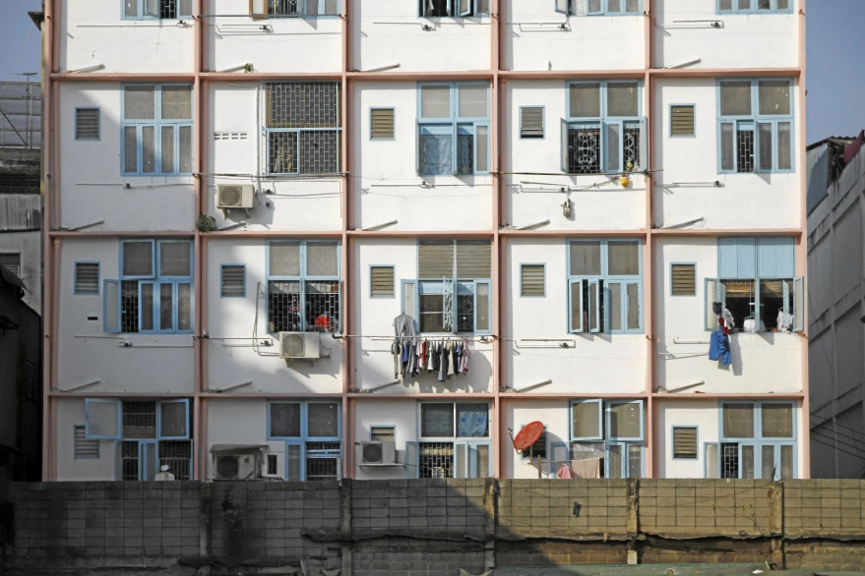
New Leonem

This area has apartment buildings and it is close to Leonem’s railway station. Many people from minority groups in Leonem live in this area.

Old Leonem
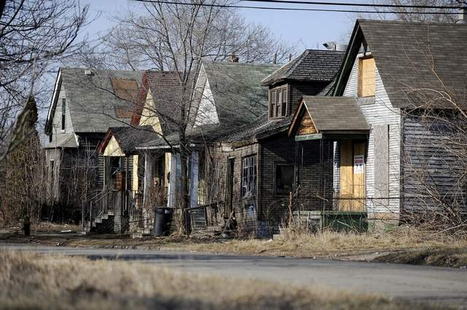
Old Leonem has mainly houses. Many elderly people in Leonem live in this area. There are not many amenities nearby.

