Should Euthanasia be Legalized?

Lesson plan for a class debate

Suggested length: 3-5 class periods (45-55 minutes each)

Lesson components:

- Opener (10-15 minutes)
- Activity
  - Part A: Preparing for the class debate (focus of 2-3 class periods).
  - Part B: Conducting the debates (focus of 1-2 class periods).
- Optional closer (10 minutes)

Assessment

Students will be assessed on their performance and arguments during the debate.

If you opt to have student judges, these students can be assessed on a written composition, in which they state the reasons for their vote and how they might have argued any points differently than the students who directly participated in the debate.

See suggested rubrics for both assessments in provided materials.

Tips

This lesson plan suggests debate teams of 3-4 students, as our experience in conducting class debates suggests that this is optimal. The lesson plan also suggests a method for holding 2 debates simultaneously to economize class time. However, feel free to modify the debate instructions as you see fit for your class.

Encourage students to use a piece of paper to communicate with teammates during the debate, so that they do not interrupt the speaker and waste time.

Expect a 3-on-3 debate to take approximately 22 minutes. Expect a 4-on-4 debate to take just under 30 minutes.

Opener (10-15 minutes)
- Share the article “Canada opens door to expanding assisted dying” with the class and direct students to read it.

- Explain that several countries, including Switzerland, Spain and the Netherlands, as well some US states, have legalized euthanasia for the terminally ill.

- Explain that students will hold a structured debate regarding whether euthanasia should be legal in such cases.

Activity

Part A: Preparing for the class debate (focus of 2-3 class period)

- Distribute and go over the student instructions and assignment rubric(s).
- Divide the students into groups of 6 or 8, and split each group into 2 teams: pro-euthanasia and anti-euthanasia.

TIP: If your class size means that you will have some teams of 3 and some teams of 4, try to ensure that individual debates will be 3-on-3 or 4-on-4. It is ok if a debate must be 3-on-4: just ensure that the team with more speakers goes first.

TIP: If any students in your class do competitive debating as an extracurricular activity, it may be best to keep them as judges and have them conduct deliberations. That way, the resulting debates are fairer.

- Distribute and go over the graphic organizer.

- Students prepare for the debate by exploring the Kialo discussion and filling out the graphic organizer with their teams.

Optional extension (5 min.): To avoid wasted time on the day of the debates, you can review the debate procedure during the class period prior to the debates.

Part B: Conducting the debates (1-2 class periods)

- To conduct 2 debates simultaneously and economize class time, you can:

  - Hold both debates in the same noise-dampening space, like a cafeteria or outside, OR
  - Hold one debate in your classroom and hold the other in a separate room.

- Set up the classroom(s) for a debate:
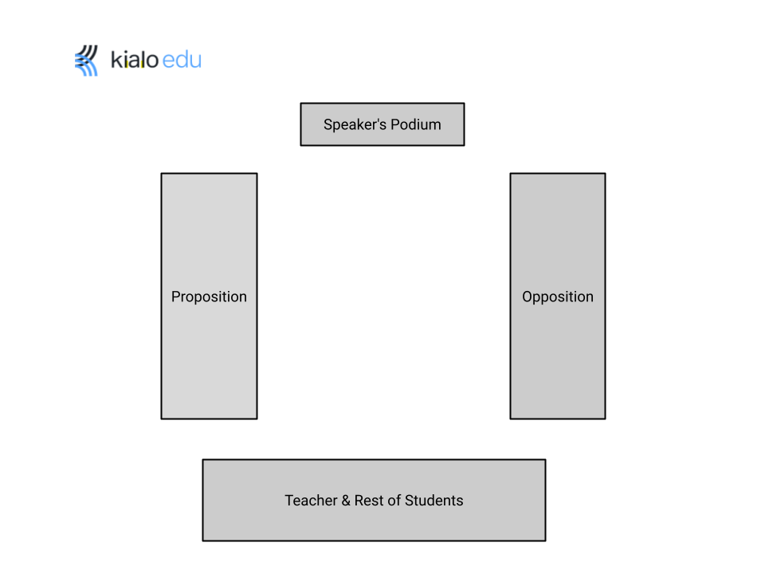
- Begin the debate(s).

- You should watch and assess one of the debates as it happens. Direct students in the other debate to make a video recording, so you can assess these students later.

- After the debate is finished, all judges have a 5 minute deliberation and decide which team has won the debate. One judge should provide a quick justification for the decision.

Optional extension: The winners of the two simultaneous debates can have their own “final” debate, in front of the whole class during a subsequent class period. This would require a total of four teams initially.

Optional closer (10 minutes)

- Have a class discussion on what students actually think about the main thesis: Should euthanasia be legalized? What are the risks and are they “worth it”?

