Were the “Dark Ages” Really So Dark?

Lesson plan for developing a Kialo discussion

Suggested length: 2 class periods (45-55 minutes each)

Lesson components:

- Opener (9-20 minutes)
- Activity
  - Part A: Balancing the Kialo discussion (focus of 1 class period)
  - Part B: Developing new sections of the Kialo discussion (focus of 1 class period)
- Optional closer (1 minute)

Assessment

Student groups will be assessed on their contributions to the Kialo discussion. (see suggested rubric in provided materials)

Tips

Up to three student groups can work on one clone of the discussion. If you would like students to work in smaller groups, then create more than one clone of the discussion.

Opener (7-18 minutes)
- Pose the following question to the whole class: “What do you think of when you hear the term Dark Ages?” Conduct a brief discussion of students’ answers.

- State that historians no longer speak about the “Dark Ages,” but instead prefer the term Early Middle Ages to describe the period after the fall of Rome in 476 CE to about the year 1000. Next, ask students to discuss their answers to the following question in pairs: “Why do you think historians might have changed the way they refer to this period?”

- Invite students to share their answers with the whole class.

Optional extension (11 min.): Activate students’ knowledge by showing the TEDed video “The Dark Ages...How Dark Were They, Really?”

- Explain that students will do a Kialo-based research activity in which they refute the unfair characterization of the “Dark Ages.”

Activity

Part A: Balancing the Kialo discussion (focus of 1 class period)

- Display the topology diagram of the Kialo discussion (see graphic below—this can be found by clicking the button in the top-left corner of the discussion). Hover over top-level claims to display their text, and explain that these top-level claims are all myths or misconceptions about the Early Middle Ages (they are all clearly marked as “MYTH”).

- Explain that the lower-level claims are all true, or at least supported by some historians; however, these claims on their own present an unbalanced view of the Early Middle Ages, which plays into the myths.

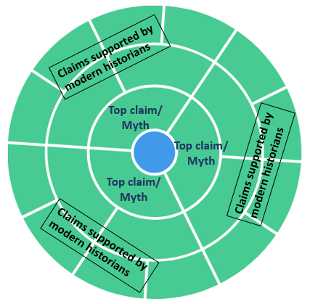

- Distribute student instructions and go over Part A with the class.

TIP: When explaining the students’ task to add cons, explain that appropriate cons should refute or temper the claim that they are attached to. You can model this by taking the claim “Without the vast Roman economy, people’s quality of life deteriorated” and adding the con “Life expectancy in the Early Middle Ages was roughly equal to life expectancy in the Roman Empire.”

Optional differentiation: You can require students to not only link sources in their claims, but to provide properly formatted academic citations in the Quote/Note box.

- Show the suggested readings within the Kialo background info (this can be found by clicking the button in the top-left corner of the discussion).

Optional differentiation:
Option 1: Share suggested readings with only some students, while directing higher-performing students to locate their own sources
Option 2: Direct the whole class to locate their own sources.
In either case, a version of the Kialo discussion without suggested readings in the background info can be found here. If you decide to use both the “guided research” and “independent research” versions of the discussion, be sure to have a clone of both.

- Direct students to form groups. Assign each a different top-level claim (i.e. common myth).
- Instruct students to log into the Kialo discussion and begin working.

TIP: If you have more than one clone of the discussion, it is ok for two student groups to work on the same myth, but each in a different clone of the discussion.

Part B: Developing new sections of the Kialo discussion (focus of 1 class period)

- Refer back to student instructions and go over Part B with the class.

- Direct students to begin researching and creating their own sections of the discussion.

Optional closer (1 minute)

- Share the following quote from American author James A. Michener:

“An age is called Dark not because the light fails to shine, but because people refuse to see it.”

