Was Columbus a Hero?

Lesson plan for a class trial of Christopher Columbus

Suggested length: 4-6 class periods (45-55 minutes each)

Lesson components:

- Opener (10-15 minutes)
- Activity
  - Part A: Organizing the trial (focus of 1 class period)
  - Part B: Researching for the trial (focus of 1-2 class period)
  - Part C: Preparing for the trial (focus of 1-2 class periods)
  - Part D: Trial (focus of 1-2 class periods)
- Optional closer (2 minutes)

Assessment

Students will be assessed as a team, based on the quality of the research and argumentation they provide in the trial.

If you opt to create a student jury, then these students can be assessed on a written composition, in which they state the reasons for their vote and how they might have argued any points differently than the students who directly participated in the trial.

See suggested rubrics for both assessments in provided materials.

Tips

If there are “extra” students, you may opt to make a jury of non-speaking students who must come to a consensus on the verdict.

Opener (10-15 minutes)
- Mention the existing controversy surrounding Columbus. Conduct a brief discussion of students’ views and explain that students will conduct a mock trial on this topic.

- Ask students: How is our understanding of history affected by the perspectives of those who write history? If history is virtually always biased to some degree, how can we build accurate understandings of the past?

- Invite students to share their views with the class and identify a set of different arguments being made.

Activity

Part A: Organizing the trial (focus of 1 class period)

- Distribute student instructions and go over Part A with the class.

- Divide students into groups.
- Each team will have at least 8 members.
- 1 member of each team will give the opening and closing statements, respectively.
- 3 members of each team will act as attorneys to examine their 3 witnesses.
If you wish to add more witnesses, there should be one attorney on each team for every witness.

- Direct students to choose their roles within their teams.

Optional Extension (5-20 min.): Activate students’ knowledge by showing them the Zinn Education Project’s video on “The Columbus Controversy.” The video provides a good overview of the topic, but you can opt to only show the introduction.

Part B: Researching for trial (focus of 1-2 class period)

- Go over Part B of the student instructions with the class.

- Direct students to begin exploring the Kialo discussion and performing further research. They can also find extra sources by clicking on the icon (in the top-left corner of the discussion) and finding the background info.

Part C: Preparing for the trial (focus of 1-2 class periods)

- Group students by team and role.

- Go over Part C of the student instructions.

TIP: You can decide to use a second class period for trial preparation if students need more time. By the end of this part, both teams should have opening speeches written and a set of clear questions to ask witnesses.

Optional extension (5 min.): To speed up the process on the day of the trial, have students also go over the diagram in Part A of the student instructions before the class period with the mock trial begins. You can do this at the end of the preparation phase.

Part D: Mock trial (focus of 1-2 class periods)

- Set up the classroom to resemble a courtroom:
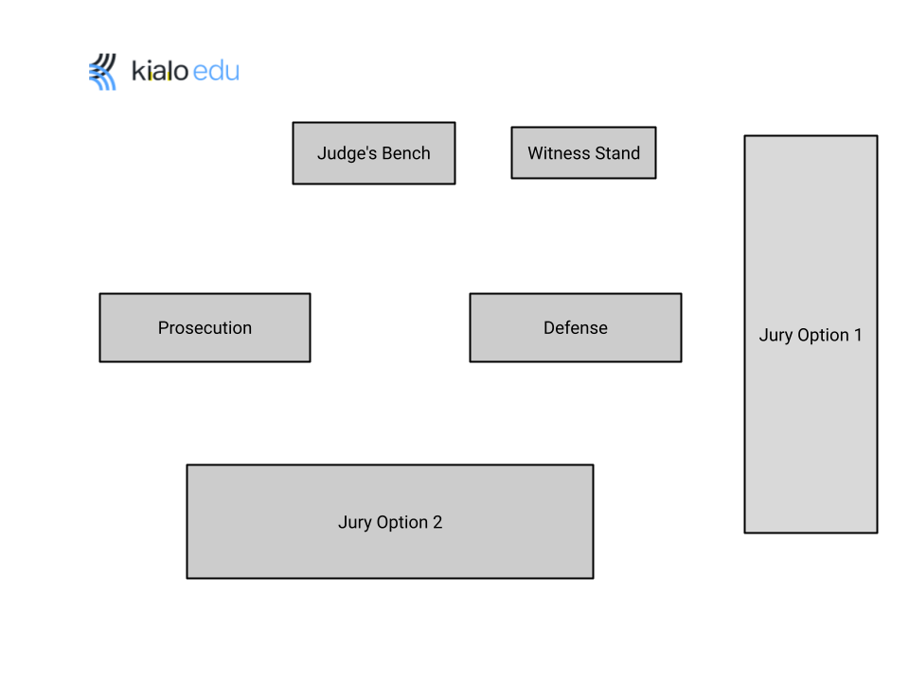

- Mock trial begins.

TIP: You can split the mock trial into two class periods if needed. A natural stopping point might be after both sides have finished their examinations of the prosecution’s witnesses.

- After the trial is done, the judge or jury comes to a verdict, explaining whose arguments have been most persuasive.

Optional differentiation: You can require the jury to have a 5 minute deliberation where they briefly discuss their views on the trial and decide which team argued their position most effectively. You can appoint a “jury foreman” to deliver the verdict.

Optional closer (5-10 minutes)

- Ask students: Is history really always written by the victors? Can we ever truly understand history without reading the perspectives of those who disagree with the dominant narrative?

- Invite students to briefly explain how the controversy surrounding Columbus has affected their answers to these questions.

