Which Bronze-Age Civilization Would be Better to Live in: Egypt or Mesopotamia?

Lesson plan for a class debate

Suggested length: 5 class periods (45-55 minutes each)

Lesson components:

- Opener (5-15 minutes)
- Activity
  - Part A: Organizing the debates (focus of 1 class period)
  - Part B: Researching ideas and preparing for the debates (focus of 2 class periods)
  - Part C: Conducting the debates (focus of 2 class periods)
- Optional closer (2 minutes)

Assessment

A series of class debates on the topic: Which Bronze-Age civilization would be better to live in: Egypt or Mesopotamia? In each debate, the assigned students will consider this question from the perspective of a different group (a common worker, a woman, a business owner, etc.). Students can be graded individually or as a group. (see suggested rubric in provided materials)

Tips

This lesson plan suggests debate teams of 3-4 students, as our experience in conducting class debates suggests that this is optimal. The lesson plan also suggests a method for holding 2 debates simultaneously to economize class time. However, feel free to modify the debate instructions as you see fit for your class.

Expect a 3-on-3 debate to take about 35 minutes at most and 4-on-4 debate to take about 45 minutes at most.

Encourage students to use a piece of paper to communicate with teammates during the debate, so that they do not interrupt the speaker and waste time.

Opener (5-15 minutes)
- Spark student interest by posing one or both of the following questions to the whole class and conducting a brief discussion around students’ answers:
- Which do you think is more important for a society: being the best at arts, culture, and science, or being the most powerful militarily?
- Which society would you rather live in: A freer society, or a more stable, secure society?

- Explain that these are good questions to consider when dealing with today's topic: Which Bronze-Age civilization would be better to live in: Egypt or Mesopotamia? Inform students that they will conduct a class debate on this topic, using:

  - The present class period to learn about the structure of the debates, choose topics, form teams, and begin researching ideas.
  - The next 2 class periods to research ideas and prepare the debate, centered around the exploration of a Kialo discussion.
  - 2 class periods to conduct a series of debates.

Optional extension: Activate knowledge by showing the TEDed videos “A day in the life of an ancient Babylonian business mogul” and “A day in the life of an ancient Egyptian doctor.”

Activity

Part A: Organizing the debates (focus of 1 class period)

- Distribute the student instructions and go over them with the class. Distribute and go over the rubric.

- State the number of students per team (e.g. 6 teams of 3 and 2 teams of 4 for a class of 26 students) and assign or allow students to choose their debate topics and teams.

TIP: If your class size means that you will have some teams of 3 and some teams of 4, try to ensure that individual debates will be 3-on-3 or 4-on-4. It is ok if a debate must be 3-on-4, but be sure that the team with more speakers begins the debate.

- Distribute the graphic organizers and go over them with students.

- Direct students to begin consulting the Kialo discussion for ideas on the topic while taking notes and/or filling out the graphic organizers.

TIP: Encourage students to explore the entire Kialo discussion, not just the branches whose top claims support the students’ chosen civilization. Useful information can be found in all branches of the Kialo discussion.

Optional differentiation: You can direct students in need of a greater challenge to also search for information from additional sources.

Part B: Researching ideas and preparing for the debates (focus of 2 class periods)

- Direct students to group themselves in their teams and to continue consulting the Kialo discussion for ideas on the topic, while taking notes and/or filling out the graphic organizers.

- After giving students time to research, direct them to prepare for the debates using the notes that they took while exploring the Kialo discussion. Advise students to use the structure of the “main arguments” graphic organizer as a template for the content and order of their remarks.

Part C: Conducting the debates (focus of 2 class periods)

- To conduct 2 debates simultaneously and economize class time, you can:

  - Hold both debates in the same noise-dampening space, like a cafeteria or outside, OR
  - Hold one debate in your classroom and hold the other in a separate room.

- Have students configure their debates as shown in the image below. Assign the 2 inactive teams to judge the 2 debates happening.
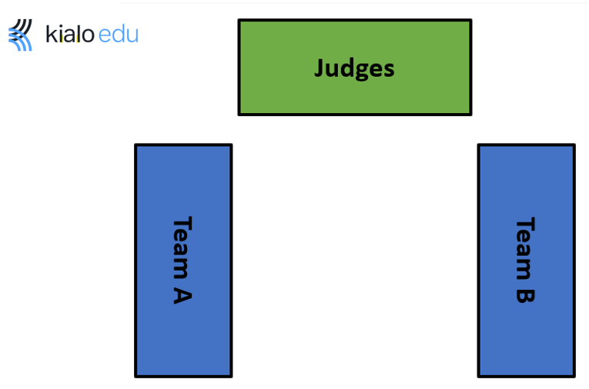

- You should watch and assess one of the debates as it happens. Direct students in the other debate to make a video recording, so you can assess these students later.
- When a debate is over, direct the student judges to vote on the winner.
- Repeat the above steps a second time, for a total of four debates.

Optional closer (2 minutes)

- Invite students to consider the timespan of Bronze-Age Egypt and Mesopotamia: more than 2,000 years, or about as long as the time between Julius Caesar and today. Explain that Bronze-Age Egyptians and Mesopotamians probably thought that their incredibly old civilizations would last forever, when of course they did not. Invite students to consider that no civilization, even our own, is immune from collapse.

- Share a quote from The Red Pyramid, a novel by American author Rick Riordan:

“The Ancient Egyptians were not fools, Carter. They built the pyramids. They created the first great nation state. Their civilization lasted thousands of years.”

“Yeah,” I said. “And now they're gone.”

