Instructions for Students: Class Debate

The gist 📌

In this lesson, you will explore a Kialo discussion on the question, “Which Bronze-Age Civilization Would be Better to Live in: Egypt or Mesopotamia?” After exploring the Kialo discussion, you will get to think about this question from the perspective of a particular group and debate your opinion with your classmates.

Activity instructions

Part A: Organize the debates 💡

- You and your classmates will be on a team to debate one of the following topics. Debate topics take the main question of the Kialo discussion and think about it from the point of view of a particular group. Teams will take the side of either Egypt or Mesopotamia, with 3-4 students on each team.

Topic 1: Would Bronze-Age Egypt or Mesopotamia be a better place to live for a common worker? | Topic 2: Would Bronze-Age Egypt or Mesopotamia be a better place to live for a soldier?
Topic 3: Would Bronze-Age Egypt or Mesopotamia be a better place to live for a business owner? | Topic 4: Would Bronze-Age Egypt or Mesopotamia be a better place to live for a woman?

- There will be 4 debates in total: 1 for each topic. To speed everything up, there will be 2 debates happening at the same time. When your team is not debating, you will act as judges for one of the debates that is happening. You may also need to make a video recording of your debate so that your teacher can watch it later.

- During debates, the teams and judges will be set up like this:

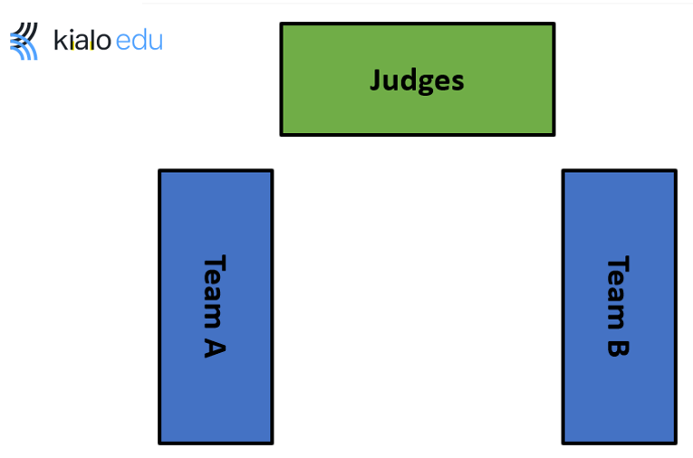
- In the debates, each team member will present an argument in favor of their chosen civilization (Egypt or Mesopotamia) by speaking about it for 1½–2 minutes. After each speaker, members of the opposite team will have 3 minutes to ask the speaker questions, with the goal of poking holes in the speaker’s argument. Teams will alternate speakers, as shown below:

- Team A’s 1st speaker makes an argument (1½–2 minutes)
  - Team B questions Team A’s 1st speaker (2–3 minutes)
- Team B’s 1st speaker makes an argument (1½–2 minutes)
  - Team A questions Team B’s 1st speaker (2–3 minutes)
- Team A’s 2nd speaker makes an argument (1½–2 minutes)
  - Team B questions Team A’s 2nd speaker (2–3 minutes)
- Team B’s 2nd speaker makes an argument (1½–2 minutes)
  - Team A questions Team B’s 2nd speaker (2–3 minutes)
- Repeat this process for the remaining speakers.
- When the debate is over, student judges take 5 minutes to discuss and vote on the winners of the debate.

Part B: Explore the Kialo discussion and prepare for the debate 👀💪

- Go to the Kialo Edu website to explore the Kialo discussion, “Which Bronze-Age Civilization Would be Better to Live in: Egypt or Mesopotamia?”

- Working with others on your team, use the graphic organizer for main arguments to note ideas for your arguments in the debate.
- Using the graphic organizer for questions, take some time to think about arguments that the other team might make. Come up with a list of short questions (no more than 3-4 sentences) that can challenge the other team’s arguments.

TIP: Make sure to look through the entire discussion for information to support your point of view. Top claims that support one civilization will have points underneath them that support the other civilization.

Part C: Debate! 💬

- Follow the directions in Part A for your class debate.

- Enjoy the back-and-forth of debating your classmates!

