Instructions for Students: Class debate

The gist 📌

In this lesson, you will explore a Kialo discussion on the question, “Should Euthanasia be Legalized?” After exploring the Kialo discussion, you and your classmates will split up into teams and conduct debates.

Activity instructions

Part A: Preparing for the class debate ✍️

- You and your classmates will be split into teams. Each team will have at least 3 members. There are three roles in the debate:

    - Arguments (2-3 speakers per team)
These will be the first set of speeches. The purpose of these speeches is to provide one concise and persuasive argument for your side. Explain why your argument is true and why it should be considered to be important.
    - Rebuttals (1 speaker per team)
These will be the last two speeches of the debate. These speeches should seek to explain why the arguments made by the other side are incorrect and unimportant. They should also seek to end the debate on a persuasive note.
    - Judges
Judges will not have a speaking role in the debate, but will be tasked with following the debate and assessing which side has won.

- During the debate, speeches will alternate between the proposition (pro-euthanasia) and opposition (anti-euthanasia) sides, as shown below:

- Proposition speaker 1 makes an argument (maximum 3 minutes)
- Opposition speaker 1 makes an argument (maximum 3 minutes)
- Proposition speaker 2 makes an argument (maximum 3 minutes)
  - Repeat this process for the remaining argument speakers
- Proposition rebuttal speaker makes their speech (maximum 3 minutes)
- Opposition rebuttal speaker makes their speech (maximum 3 minutes)

- Go to the Kialo Edu website to explore the discussion “Should Euthanasia be Legalized?” Look at claims from all sides of the discussion to be aware of the arguments your opponents will make and find ways to refute them. Also take a look at the sources linked in the claims to gain a wider understanding of the issue and gain an upper hand over your opponents.

- Coordinate with your team to decide which arguments you will prioritize, and which speakers will bring which points. Try giving entire branches from the Kialo discussion to different speakers to ensure that each one has something unique to say and different speakers do not cover the same material.

- Plan out your speech by using the graphic organizer.

- Judges can prepare together as well, exploring the Kialo discussion and discussing how they would argue for both sides.

Part B: Debate 💬

- Set up your classroom for a debate:
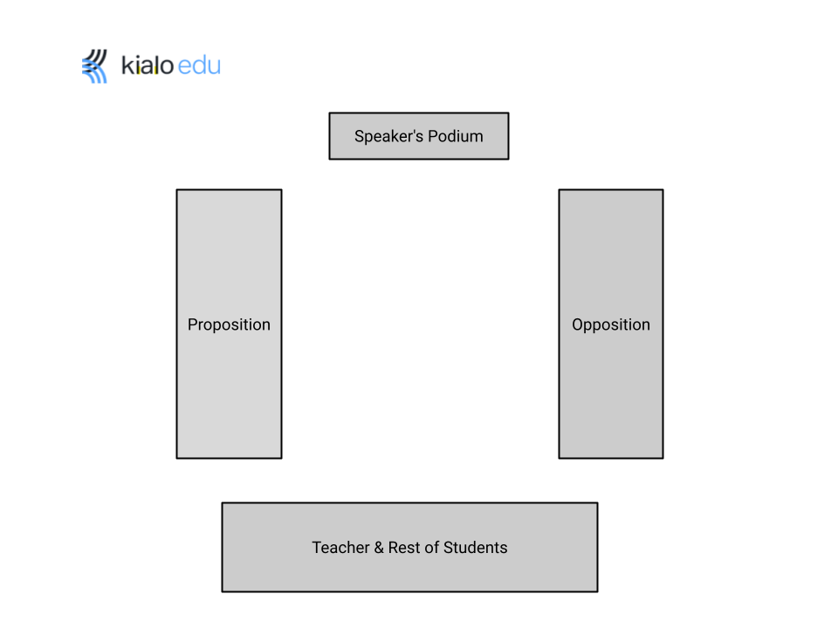
- Start the debate. If two teams are debating in a different room, the judges should set up a computer or tablet to record the debate.

- After the debate is done, the judges will deliberate in an area away from the debaters for no more than 5 minutes. When judging, try to break down the debate into specific disagreements made during the debate. Ask who won on each issue and which issue was most important. At the end, have a vote to decide which side has won.

- If two teams are debating in a different room, the judges must send the recording of the debate to the teacher.

