Instructions for Students: Balancing a Discussion

The gist 📌

In this lesson, you will balance a Kialo discussion on the question, “Were the ‘Dark Ages’ Really So Dark?” The top-level claims in this discussion are all common myths about the so-called “Dark Ages.” Meanwhile, the sub-claims are all facts, or at least supported by many historians. On their own, however, these facts play into the myths.

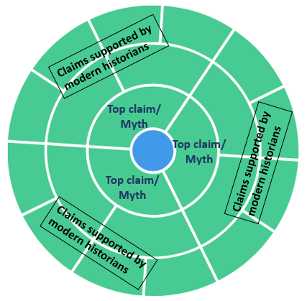

Your job will be to balance out these facts with more facts, so you can get a fair picture of the Early Middle Ages. Working with a group, you will conduct research and add these balancing claims to the discussion.

Activity instructions

Part A: Balancing the discussion ⚖️

- Form a group and understand which myth your group will work to dispel.
- There are six “pro” claims (green) under your group’s assigned myth. To each of these six pros, you will add one “con” claim (red) that would refute or temper the pro. Remember to link a source for your claims, and quote!

- When all groups have finished, the discussion should look like this:
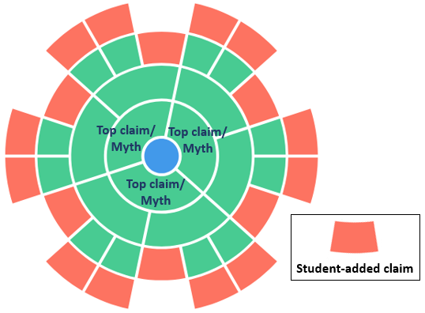

- Find credible sources that refute your assigned myth. Use the information in these sources to form your six cons. Link to these sources in your claims, and quote them!

Part B: Developing new sections of the Kialo discussion ✍️

- Working with your group, start a new section of discussion under your assigned myth. Do this by creating a con (red) that directly refutes the myth. This con does not have to include a source, but make sure you can back up your con with evidence.
- Conduct more research to find verifiable information that supports your new con.

- Using the information you have gathered, provide three pros (green) to support your new con. The pros should all include sources. When all groups have finished, the discussion should look like this:
