Should Kids Be Able to Have Social Media Accounts?

Lesson plan for expressing opinions in writing or speech

Suggested length: 2 class periods (45-55 minutes each)

Lesson components:

- Opener (5-10 minutes)
- Activity
  - Part A: Exploring the Kialo discussion and voting on claims (30 minutes)
  - Part B: Introducing the assessment and reviewing votes (10-15 minutes)
- Optional closer (5-10 minutes)

Assessment

Students will write a short essay or deliver a 2-minute speech on the prompt, “Should kids be able to have social media accounts?”

Opener (5-15 minutes)
- Spark student interest by asking about students’ experiences and/or impressions of social media with the following questions:

  - What are some of the benefits and drawbacks of social media?
  - What do users need to watch out for when using social media?
  - Most social media platforms have a requirement that users be at least 13. Why do you think this is?

Optional extension (6 min.): Activate students’ knowledge by showing the
Common Sense Education video “When is the Right Age to Start Social Media?”

- Inform students that they will explore a Kialo discussion on the question of whether kids should have social media accounts.

Activity

Part A: Exploring the Kialo discussion and voting on claims (30 minutes)

- Display the topology diagram of the Kialo discussion by clicking the button in the top-left corner of the discussion.
  - Assign half of the class to explore the “pro” side of the discussion. Students in the “pro” group will explore all the claims under the two green claims nearest the center.
  - Assign the other half of the class to explore the “con” side of the discussion. Students in the "con" group will explore all the claims under the two red claims nearest the center.

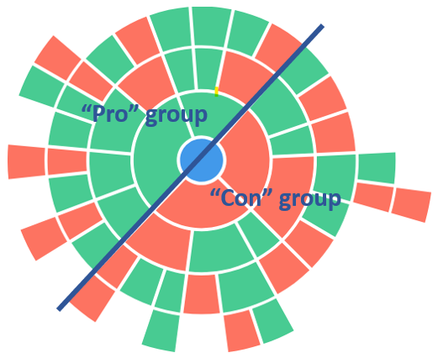
- Tell students that they will explore their assigned half of the Kialo discussion and vote on at least 20 claims. Remind students that voting is not a question of agreeing or disagreeing, but how interesting or convincing they find a claim. Allow them to vote in pairs or by themselves.
TIP: You may wish to demonstrate voting to your students. Pick a claim and model how to give it different scores, explaining that “0” means “this point is not interesting or convincing,” and “4” means “this point is extremely interesting and convincing.” You can then revoke your demonstrational vote by clicking on the score again.

- Direct students to log into the discussion to begin exploring and voting.
TIP: You can keep track of how many times each student has voted by pressing the ≡ button in the top-left of the discussion and looking at the “Tasks” tab.

- When there are only a few minutes left in this part of the activity, instruct students to vote on the discussion’s thesis, with “4” being “strongly agree” and “0” being “strongly disagree.”

Part B: Introducing the assessment and reviewing votes (10-15 minutes)

- Inform students that they will have a choice to either write a short opinion essay or give a 2-minute speech on the prompt, “Should kids be able to have social media accounts?”
- Tell students that they can use their own and their classmate's votes in the Kialo discussion to help them identify some of the best points for their essays or speeches. To do so, tell students that they will now look at how the two groups voted.
- In the discussion settings, go to “Users’ votes on claims are visible for” and select “All participants” if it is not already selected.
- In the top-left of the discussion, under “Perspectives,” click “All” and change to “Supporters.” Show students the topology diagram again (click the button). Explain to students that this is how supporters of the thesis voted on claims, so if students would like to write or speak about how kids should not have social media accounts, the darkest-colored claims are some of the best ideas to use.
- Repeat step 3 above for “Opponents.”
Optional closer (5-10 minutes)

- Change the “Perspective” setting back to “All” and display the discussion’s topology diagram (click the button). Then ask students:
  - What seem to be the most popular claims overall?
  - What seem to be the least popular claims overall?
  - Why did you vote the way you did on these claims?

