Instructions for Students: Class Trial of Christopher Columbus

The gist 📌

In this lesson, you will explore a Kialo discussion on the question, “Was Columbus a Hero?” After exploring the Kialo discussion and conducting some additional research, you and your classmates will split up into two teams and put Columbus on trial.

Activity instructions

Part A: Organizing the trial 💡

- You and your classmates will be split into two teams: Columbus’ defense and the prosecution. Each team will have at least 8 members, as follow:
  - 1 opening speaker
  - 1 closing speaker
  - 3 attorneys (at least)
  - 3 witnesses (at least)

- The trial will have three parts:
  - Opening statements
Each side will make an opening speech to present their strongest arguments and outline their case for the rest of the trial. These speeches should be 2-3 minutes in length. Although there can only be one opening speaker, your entire team can work together to prepare the opening remarks.
  - Examination and cross-examination of witnesses
Each side will have a list of witnesses they wish to call up. The side that calls the witnesses will get the chance to ask their questions first. Then the opposing side will be able to cross-examine that same witness by asking their own questions. Each witness should be questioned for 2-4 minutes total (1-2 minutes by both sides).
  - Closing remarks
At the end, each side can restate their case, respond to the most effective claims made by the opposing side and conclude on a powerful rhetorical note. These speeches should be between 2-3 minutes. Although there can only be one closing speaker, your entire team can work to prepare the closing remarks.

- On the day of the trial, the stages will unfold as follows:

- Opening statements  (2-3 min. each) | → | - Witness examinations  (1-2 min. each) | → | - Closing statements  (2-3 min. each)
- Prosecution opening statement  - Defense opening statement |  | - Prosecution witness 1: examination, cross examination  - Prosecution witness 2: examination, cross examination  - Prosecution witness 3: examination, cross examination  - [Repeat for 3 defense witnesses] |  | - Prosecution closing statement  - Defense closing statement

- If you are a witness: Witnesses should not make up facts when asked questions; their testimony must be clearly based on class materials or factual research. Witnesses are allowed to say they do not know the answer to a question.

  - The prosecution should call John Cabot, another crew member and a Taino Indian as witnesses.
  - The defense should call Christopher Columbus, a crew member from his expedition and Queen Isabella as witnesses.

- If you are an attorney: You will question, or "examine," one of your team’s witnesses. Each team should have one attorney per witness. After the first examination, an attorney from the other team will then get the chance to “cross-examine” the witness by asking their own questions.

  - In the first examination, attorneys should ask short and direct questions, allowing witnesses to tell their story and perspective in their own words.
  - During cross-examinations, attorneys should attempt to show that the witness called does not have a good or representative perspective, is biased in some way or is not telling the full truth about their experience. (Here are some tips on cross-examination.)

Part B: Researching for the trial 💪

- Go to the Kialo Edu website to explore the discussion “Was Columbus a Hero?" and begin taking notes. Remember to look at claims from all sides of the discussion. This way, you should be aware of the arguments your opponents will make and find ways to refute them. Likewise, exploring the sources linked on claims is a great way to gain more knowledge and the upper hand against the other team.

- Once you have finished looking through the Kialo discussion, continue to conduct your own independent research on topics that you think will help your team’s case. You can begin with the additional sources included in the Kialo discussion background.

Part C: Preparing for the trial ✍️

- Work with others in your group to begin planning the strategy for the trial. Begin deciding what main arguments you wish to use in the opening statement.

- If you are an opening speaker: Talk with the attorneys on your side about the main points that they will try to show while examining witnesses. Present these points in your opening remarks

- If you are a closing speaker: Prepare some remarks that will reinforce the main points made by the opening speaker and attorneys. But during the trial, pay close attention and add or change your remarks to reinforce or refute any important points that come up. Be flexible!

- If you are a witness: Prepare by thinking about your character's point of view and how they would view certain events, as well as talking with the attorneys on your side so you can agree on the first questions that will be asked.

- If you are an attorney: Prepare by planning the questions you will ask your witnesses, as well as the cross-examination questions for the other side’s witnesses.

- If you have time, begin practicing your speeches and questions.

Part D: Trial 💬

- Set up the classroom to resemble a courtroom.

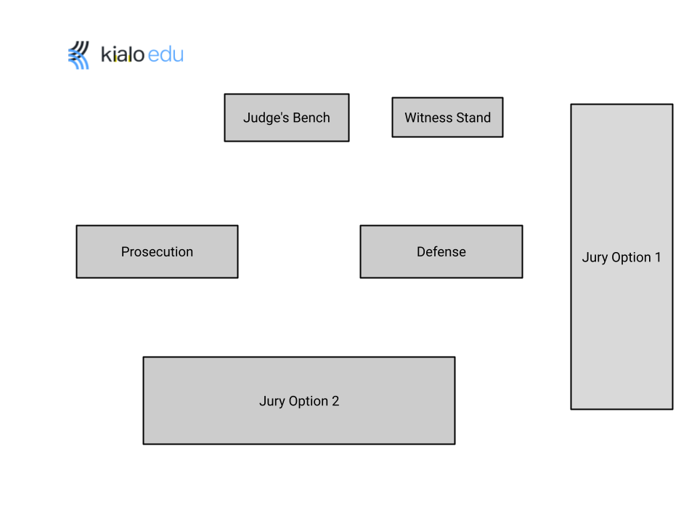
- Proceed with the trial, following the diagram in Part A.

- Have fun, and always be respectful of your fellow classmates!

