Should the 1791 French Constitution Provide All Citizens With the Same Political Power?
Group Background File

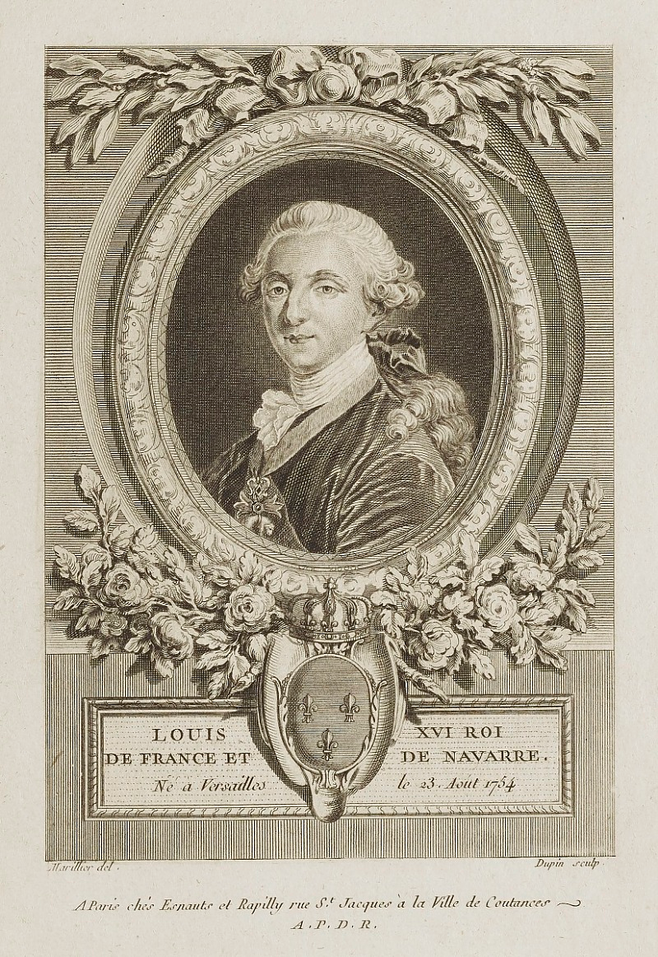
Royalists

Politically, you would prefer a system of absolute monarchy with a strong king in control. France has had a king for 1,000 years, so why change now? What you would like is to get King Louis XVI or one of his relatives back on the throne. In your opinion, leaders have a divine right to rule. Your natural allies are the nobility and the clergy because they also benefited under the old system and are afraid of what they might lose if something replaces it. You have some support from a few peasants who are loyal to their feudal lords, as well as some merchants who made money by selling and lending to the king.

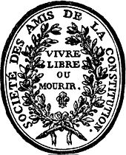
Jacobins (radicals)

Politically, you are members of this revolutionary club and want to ensure the downfall of the monarchy and rise of the French Republic. You believe that the people, rather than the king, should be in charge of the country. People should receive all the same rights, and you are not afraid to use violence to achieve that goal. Led by Maximillian Robespierre, your club's motto is to "Live free or die." You have the support of working-class people and peasants, as you seek to better their living conditions. Some liberal nobility may also support your ideas, after being influenced by Enlightenment authors such as Rousseau.

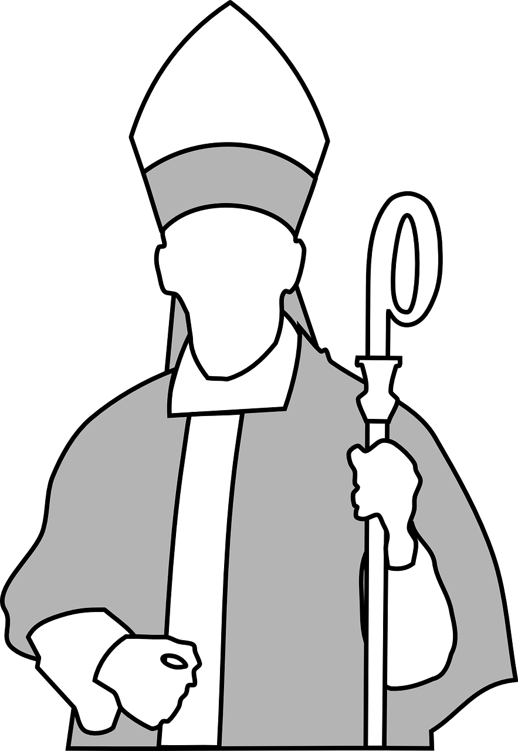
Clergy

As an ordained member of the Catholic Church, you have a unique understanding on how to access God and the afterlife. As such, you are afforded the privilege of being in the First Estate, as it is your duty to guide France's people and society. Moreover, you alone can affirm the king's divine right to rule France. Though some may think it is unfair that you are exempt from paying taxes, you feel that it is only fair that you should continue to be exempt, as you provide so much to ensure society's well-being.

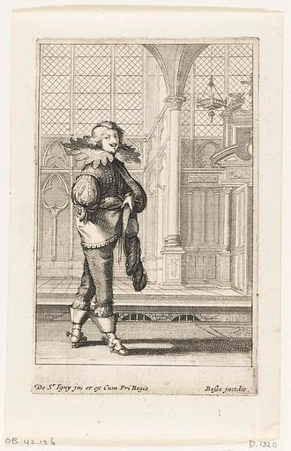
Nobility

As a member of the Second Estate, you were most likely born with an aristocratic title. Though some in the country may think of you as a wealthy individual that does nothing for the nation, you have worked hard to accumulate your wealth, engaging in commerce and trade. You may even own large pieces of land and oversee them as businesses, collecting rent and agricultural profits. Managing such large enterprises means that you should maintain your privileges from the old order, such as not having to pay personal taxes.

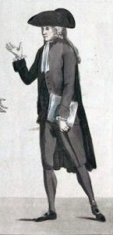

Bourgeoisie

You have made a place for yourself in society through hard work and determination. You may own a business, manage stores, or work as a trained professional such as a doctor or banker. You make enough to live a comfortable life, and may even have wealth that surpasses that of some of the nobility. However, you still belong to the Third Estate, and with that comes very little political and societal influence. As you are the economic backbone of the country, you believe that you should have a say in government rather than continuing the old system in which only the first two estates are favored.
Peasants and Commoners
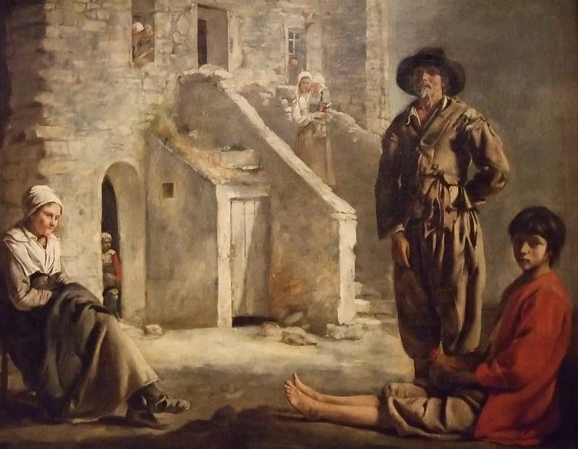
Life has not been easy, and it seems to be getting even harder. For the most part, you work on someone else's land, or as a day laborer who finds work wherever you can. You make up over 80% of France's population, and you are all part of the same group as the bourgeoisie: the Third Estate. Like all those in this estate, you are heavily taxed and have virtually no say in how the government is run. Shouldn't the rules be made to benefit you, given that you are not only the largest socio-economic group in the country, but you sacrifice the most to keep the country running?

You are sick of being on the brink of starvation despite working long hours. As such, you definitely supported the October 1789 Women's March on Versailles as you saw people representing how you felt: expressing intense dissatisfaction with how the country has been run.

